A Tale of Two Zithers
by Tony Newport
First published as Metallurgy and Music in Forty Degrees South Magazine in 2016.
Republished in America in Autoharp Quarterly in the same year
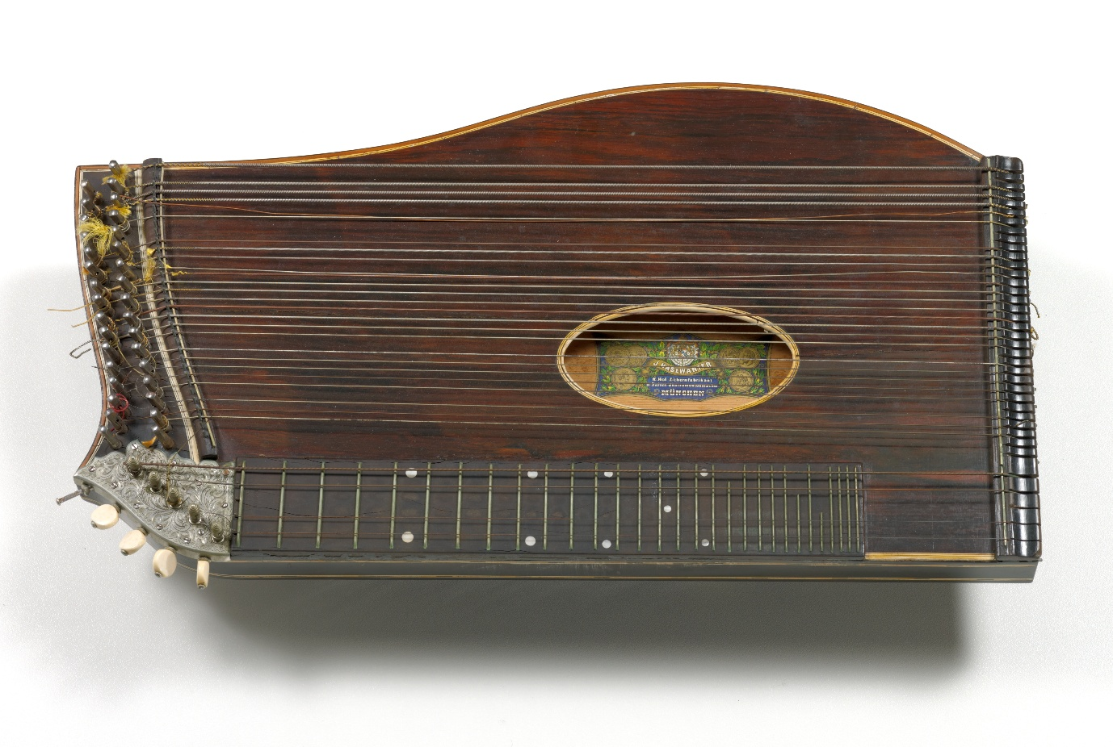
Image: Robert Sticht’s Zither courtesy TMAG: Tasmanian Museum and Art Gallery

Down here at the bottom of the world the westerly winds storm across the great southern ocean from San Antonio in Argentina, by-pass the African continent, and smash into the mineral rich west coast of our heart shaped island of Tasmania. Here in 1895 an American metallurgist arrived in the embryonic mining town of Queenstown to take up a position with the Mount Lyell Mining and Railway Company. He would go on to pioneer a revolutionary smelting technique at what was then one of the richest copper deposits in the world. That metallurgist was Robert Carl Sticht born in Hoboken New Jersey in 1856. In the years to come his passion for the arts and sciences would come to rival his professional reputation. His book collection alone included works such as Euclid's Elementa (1482) one of only three complete works in the world and Francesca Colonna's Hyperotomachia Poliphili (1499) described as the most beautiful book of the 15th Century (Source: The Latrobe Journal N79 2007 The State Library of Victoria). Sticht also played the Zither.
Even to this day in the hearts and minds of contemporary Australians Queenstown is regarded as both rugged and remote - situated as it is in mountainous terrain with an average annual rainfall of 94.8 inches, and an even bleaker average of just 29 cloudless days a year. To construct a railway the short 22 miles from the mine to the port of Strahan required the building of 48 bridges and a rack and pinion system to elevate the train up two steep gradients of 1:16 and 1:20 respectively. Those who constructed the railway which was completed in 1897 and those who laboured in the mines and smelters were of a class far removed from the well educated and sophisticated Sticht. Nonetheless at a concert he performed with his Zither in 1896 he was received, according to reports at the time: with 'rapturous applause'.

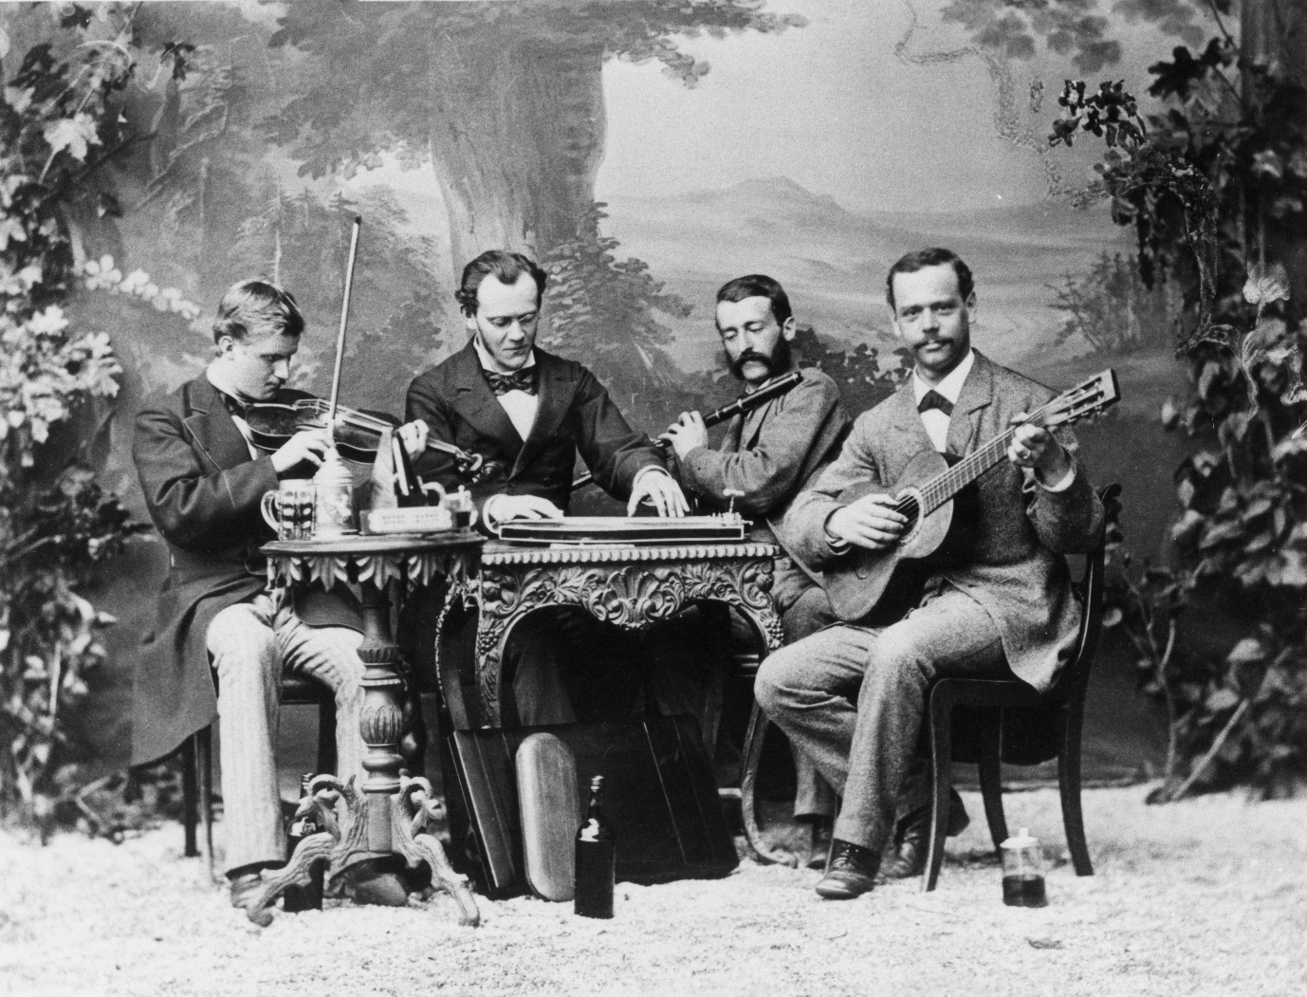
Image: Robert Sticht in Clausthal Germany 1878. Source: TMAG
In the Galley Museum in Queenstown in a room decked out in period furniture from the first three decades of the last century are two Chord-less Zithers. Both of which resemble the contemporary Autoharp. Today calling these instruments Zithers can attract opprobrium from those who claim a sole allegiance to the Concert Zither - an instrument identical to that played by Sticht. In the late nineteenth century such a distinction was far from clear - at least in regard to the generic name of Zither.
1878 was a watershed year in establishing a degree of conformity for the Zither. Ultimately it was determined, at a gathering of Zither players in Germany, to settle upon a chromatic scale with 36 strings including the finger board (The Zither Player 1885 p.4 http://www.zither.us/ files/nl0008.pdf). Prior to that there had been various numbers of strings with further variations of both diatonic and chromatic scales.
Interestingly it was around this time Karl Gȕtter was working on his design for the Volk Zither or Chorded Zither. (For the best explanation of Gȕtter and his invention of the design we recognize as the Autoharp today see the True History of The Autoharp by Ivan Stiles, The Autoharp Quarterly Vol 3 Number 3). I mention this here for one simple reason. Much has been written about the ancestry of both the Zither and The Autoharp. It cannot be a coincidence that as Zither players and composers were thrashing out a consensus on the key elements of their instrument and settling upon a chromatic arrangement with 36 strings Gȕtter was also working on a chromatic design with a similar number of strings. I leave the final say for how we choose to prosecute our differences musically - to those Zither aficionados of 1878.

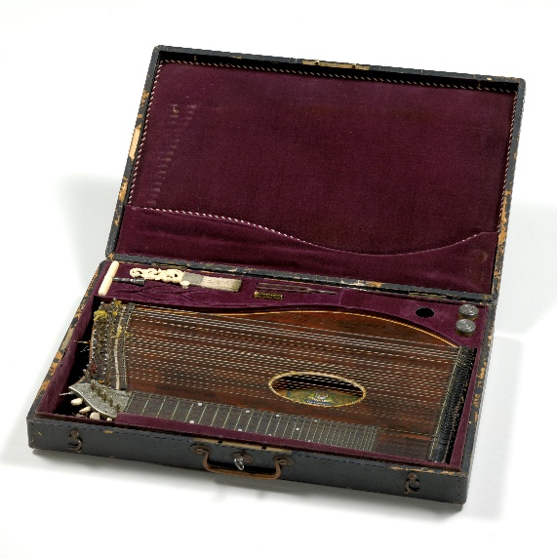
"The respective differences of opinion did not remain of a purely technical character, but pointed themselves by the introduction of private interests, to a certain degree of hatred and partisanship towards each other (The Zither Player P3)

Image: Sticht’s Zither and case. Source: TMAG
Let me say this: if the instrument was named according to its designer all Autoharp players would now be playing the Volk Zither or Chorded Zither. Let us pay homage here to German ingenuity and design and to instrument makers in general not the least George Orthey for his impact on contemporary Autoharp craftsmanship.

Much has been written about Sticht and his time as General Manager of the Mt Lyell Mining and Railway Company. Just as much has been written again about his collections and his library. Little has been written or recorded about his music. Sticht's Zither is held in storage at the Tasmanian Museum and Art Gallery. In an 1878 photograph he appears to be playing the same instrument. The instrument, its case and attachments are in remarkably robust condition over a lifetime of approximately a century and a half including, one imagines, many decades of playing.
Back at the Galley Museum it is impossible not to draw connections with Queenstown's rich heritage, the old Zithers in the parlour room and the ghost of Sticht and his residence and art sanctuary - Penghana. By sheer coincidence a tune I recently composed on the Autoharp for a selection of songs with a West Coast of Tasmania theme was named the Mt Lyell Waltz at the suggestion of Vince Brophy a well know Australian folk musician and producer. Stan Gottschalk another well known Australian folk musician, former US resident and now Australian citizen, has kindly put some notation to this tune. One has to say that the Zither - American - Australian connections keep working themselves over. One also has to add that The Mt Lyell Waltz is in 4/4 time. Let's just say Tasmania's west coasters are both gritty and a little bit quirky.

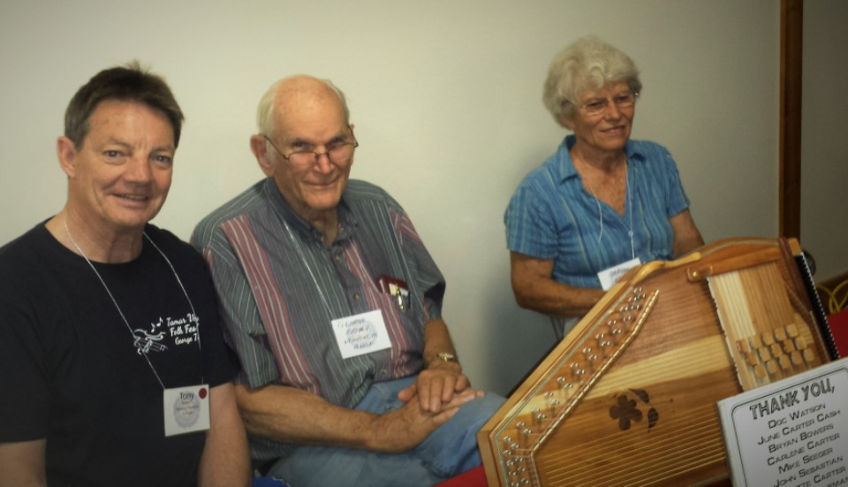
The Author with George Orthey and his wife.
Mountain Laurel Autoharp Gathering
Little Buffalo State Park. 2014

The first public performance of The Mt Lyell Waltz was conducted this year (2016) at the Tamar Valley Music Festival in George Town Tasmania and was played on Autoharp, Fiddle and Guitar. George Town is only forty minutes car journey from Launceston - the place of Sticht's death and Tasmania's second largest city and unofficial capital of the Tamar Region. If you are planning on visiting Tasmania to take in The Abt Railway - now running as The West Coast Wilderness Railway - steam engine and refurbished carriages and all; and Penghana and The Galley Museum then don't forget the Tamar Valley Festival which is held in mid January every year. The Unconformity a bi-annual festival is held in Queenstown around October.

https://tamarvalleyfolkfestival.com/

https://theunconformity.com.au/

